**PREE Team Code-a-thon, 2023**

By Stevie, Judene, and Ismael

**Research question:**

This exercise was centered on tracing the evolution and distribution of the state of mental health for adults throughout the pandemic and in its aftermath. In this process, the exercise aims to address the following research question: How did the state of mental health of adults change throughout the pandemic and how did family structure, race/ethnicity and socioeconomic status of individuals impact these outcomes?

**Methodology:**

This exercise begins by first defining the outcome variables. Mental health is captured by identifying whether or not an individual experienced symptoms associated with anxiety or depression; as such, this outcome variable was binary and placed equal weight on both symptoms of anxiety and depression. The prevalence of these symptoms was assessed during the following three phases: phase 1 includes the two-week period between April 23, 2020, and May 12, 2020; phase 2 includes the two-week period between April 28, 2021, and May 10, 2021; and phase 3 includes the two-week period between April 27, 2022, and May 9, 2022.

Each phase was carefully chosen to provide data points that are comparable over time and to ensure that this project allows for an adequate and fair distribution of labor.

Because this exercise is also concerned with the distribution of symptoms of mental health, we also classified individuals by family structure (e.g., whether or not children were present in the household), race/ethnicity, and socio-economics status. As proxies for socioeconomic status, we used the following, an individual’s level of education, confidence in meeting rent/mortgage payments, and degree of food insecurity.

**Hypotheses:**

We expect that the state of mental health of individuals improved over time since 2020, and that symptoms associated with anxiety and depressions were unevenly distributed amongst individuals by race/ethnicity, family structure, and socioeconomic status. We expect that these socioeconomic and demographic factors intersect with one another, such that the prevalence of these symptoms is higher for under-represented individuals of low socioeconomic status relative to their white and more affluent peers. This exercise is descriptive in nature and does not intend to identify causal mechanisms.

**Analysis and findings:**

After capturing the prevalence of symptoms associated with anxiety and depression since the start of the pandemic, we find the following:

* The prevalence of symptoms associated with anxiety and depression for individuals with no children and who experience food insecurity increased between 2020 and 2022 (please see figures below). This was unexpected. However, as expected, these individuals were more likely than their food secure and more affluent peers to experience these symptoms. Other measures of socioeconomic status were excluded from the visuals below as they reflected less explanatory capacity.
* In terms of racial/ethnic differences, we find that in 2022 white individuals with children are more likely to report these symptoms than their under-represented counterparts, irrespective of food security. These outcomes were also unexpected as we underestimated the extent to which communities of color under-report these symptoms.
* Interestingly, we find that amongst food insecure Asian adults, symptoms of anxiety and/or depression between 2021 and 2022 varied by the presence of children. For food insecure Asian adults with children, rates of expressing symptoms decreased between 2021-2022, whereas rates increased for adults without. These results were also unexpected.

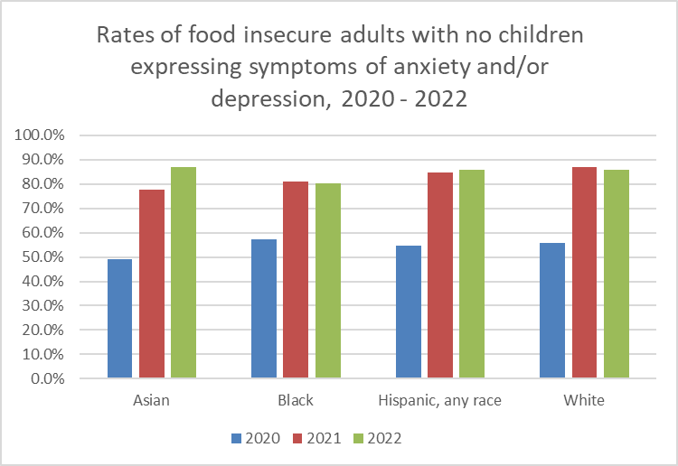

Figure 1.

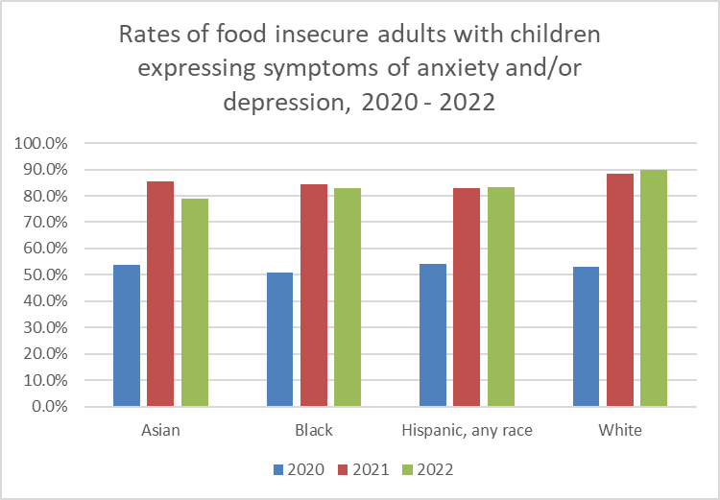

Figure 2.

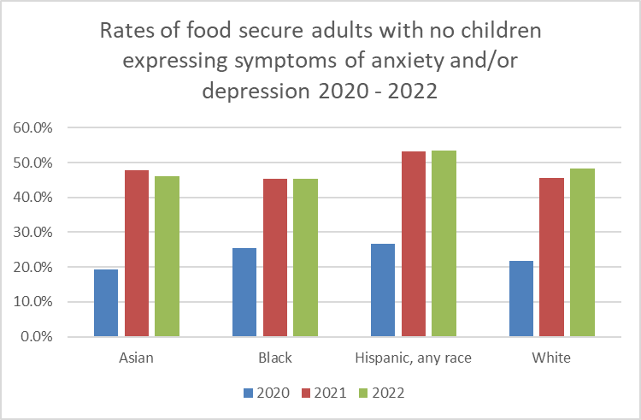

Figure 3.

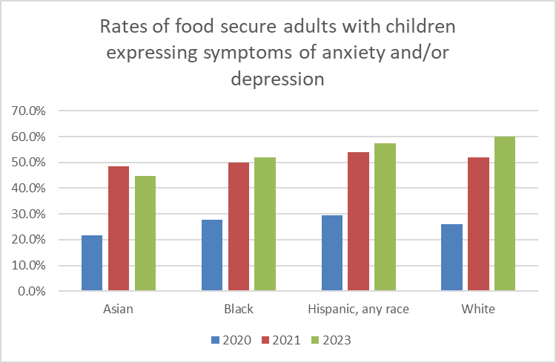

Figure 4.